SECTION A (40 MARKS)
1. Work out: 9⁰ + 10⁰ – y⁰ | 2. Multiply: 0.5 x 1.8
3. Brian is standing a line and he is the 12th from either side. How many pupils are in the line? | 4. Set T has 31 proper subsets, find the number of elements in set T.
5. Solve for k. 3k – 7 = 14 | 6. Racheal bought a skirt at Shs.96000. She sold it later and made a loss of Shs.10800. At what price did she sell the skirt?
7. Convert 200800kg to tones. | 8. Find the GCF of 6 and 15.
9. Subtract 342 _{five} – 144 _{five} | 10. Find the median integer  ⁻1, ⁺2, 0, ⁻3, ⁻5, ⁺1
11. Find the value of y in the diagram below.
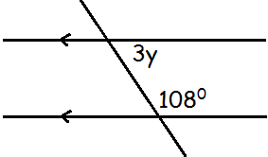

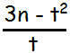  12. Given that n = 8 and t = ⁻3. Evaluate | 13. Convert 214 _{six} to denary base.
14. Write 360000 in scientific notation. | 15. Convert 2m / sec to km/hr
16. The mean of scores 8, 7, 6, 5, (a – 5) is 8, find the value of a and their Range. | 17. The circumference of a circle is 88m. Find the radius of a circle. (Use $π=\frac{22}{7}$)
18. Which number has been expanded?  (8x10⁰) + (6x10⁻¹) + (3x10⁰) + (5x10⁻²) | 19. Work out and use distributive property completely 3.6 x 18 – 3.6 x 8
20. Find the square root of 1.44

SECTION B
21(a) Simplify: $\frac{3}{8}-\frac{2}{3}+\frac{3}{4}$ (2mks) | 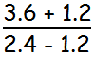  b) Solve:
22. Given that $∩$($ε$)=54, $∩$(m) = 23, $∩$(N) = 26 and $∩$(M$∪$N) = 10
a) Complete the Venn diagram below. (3mks)
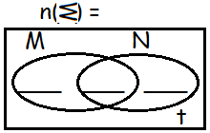

b) Calculate the value of y. (2mks) | c) Find $∩$(N – M) (1mk)
23. Mohammed drove from town P to town B at a speed of 80km/hr for $2\frac{1}{2}$ hours. He spent 30 minutes at town B while taking breakfast. Form B he went on to town C a distance of 120km while driving at a speed of 60km/hr.
a) Calculate Mohammed’s average speed for the whole journey. (4mks)

b) Michelle drove her car at a constant speed of 60km/hr. What distance did she cover in 90 minutes? (2mks)

24. Sylvia bought the following items from the supermarket.
- 3kg of beans at Shs.3200 “ kg
- $1\frac{1}{2}$kg of salt at shs.1800 every kg
- 250gm of meat at Shs.8000 “ kg
- 8 apples at Shs.1200 every 2 apples
- 4 paper bags at shs.3000.
a) How much money did she spend altogether? (4mks)

b) If she was given a discount of 10% how much money did she pay? (2mks)

25(a) Given that 23_{y} = 32_{five}. Find the missing base y. (3mks) | b) Work out 1 0 1 _{two} + 1 1 _{two} (2mks)
26(a) Find the distance around the Quadrant. (3mks)
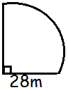

b) Find the area of the Quadrant. (2mks)

27(a) Express $\frac{1}{8}$ as a decimal fraction. (1mk)

b) Divide 3636 by 9. (2mks) | c) Work out: $1\frac{1}{3}-\frac{3}{4}$ (2mks)
28(a) Solve 3(y + 2) = 2(y + 7) (2mks) | b) Simplify: 2(m + 2) + 3(m + 3) (2mks)
29(a) Construct a triangle PQR with PQ = 6cm, = 60⁰ and = 45⁰. Use a pair of compasses, a pencil and a ruler only. (4mks)

b) Measure

c) Drop a perpendicular line through R to meet line PQ. (1mk)

30. A man spent $\frac{1}{4}$ of his salary on food, $\frac{1}{3}$ on clothing, $\frac{1}{6}$ on fees and the rest on savings. If he saves shs.4800.
i) Find the fraction sent on savings. (1mk)

ii) What is his total salary? (3mks)

31(a) Find the supplement of 105⁰  (2mks) | b) Calculate the complement of  (2x-15)⁰ (2mks)
32. The graph shows Mugisha’s journey from P to place Q and back to place P.
Use it to answer the questions that follow.
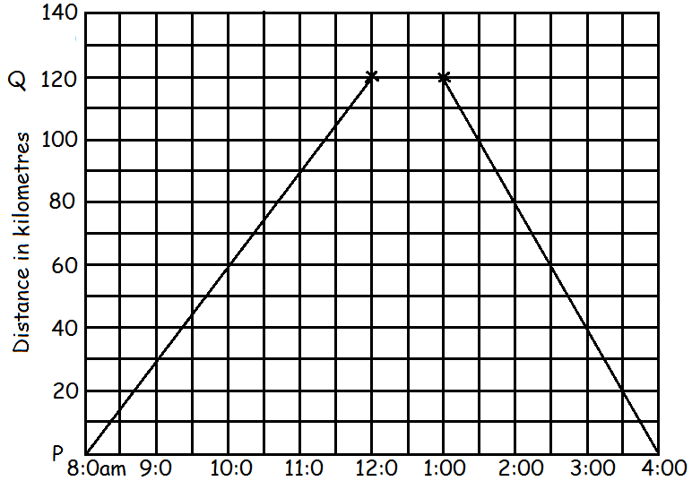

a) How long did he take to reach town Q? (1mk) | b) How long did Mugisha take or stay at place Q? (1mk)
c) Find Mugisha’s average speed for the whole journey. (3mks)

*****GOD BLESS*****

